Stop Motion Project

Name: | Joe Amadeuz Morales/Alexis Platt/  Rebeca Sanchez/ Mary Sofer

Description  /Rationale: | This project will be a stop motion video that describes your form of free speech. Today we see a lot of negativity in social media and stigma on free speech. Use this project to explore the positive side of free speech.

Essential Questions: | What mediums of artwork can be considered as a Fine Art/gallery exhibition worthy?  In what ways can art communicate an idea/belief?

State Standards: | VAPA STANDARDS:  Adv.VA:Cr1.2 Choose from a range of materials and methods of traditional and contemporary artistic practices, following or breaking established conventions, to plan the making of multiple works of art and design based on a theme, idea or concept.  Adv.VA:Cr2.1: Experiment, plan, and make multiple works of art and design that explore a personally meaningful theme idea or concept

Common Core  Standard: | CCSS.ELA-LITERACY.RL.9-10.7  http://www.corestandards.org/ELA-Literacy/RL/9-10/#CCSS.ELA-Literacy.RL.9-10.7

Analyze the representation of a subject or a key scene in two different artistic mediums, including what is emphasized or absent in each treatment

Objectives | Create a short video (between thirty seconds and one minute) using the Stop Motion Studio app. The animated video can be live-action with objects or drawn by hand (or digitally), and it should talk about the issue of freedom of speech.

Art History Connections:  1.Historical Movement  2.Artist Mentor | - Animals were painted in the caves of Lascaux, France over 20,000 years ago. Historians believe that the painted horses, bulls, and human figures were used in rituals to help these early humans become better hunters. The paintings could only be seen by the light of a fire, and the flickering light made the animals look like they were running. Do you think we can consider this an early form of animation?  - With the invention of the camera in the 1800s, photographers were able to capture live images for the first time. An American horse breeder wanted to see how his horses actually looked while they were running, so he hired a photographer to take a series of pictures of a horse and rider. Arranging the pictures in order, we are able to see the first example of what we now call motion pictures, or movies. You can see that the horse’s legs are in a different position in each individual picture, but when they are shown one after another very quickly, our eyes see this as a smooth, fluid movement.  - The Italian artist Blu has taken stop motion animation to another level, using the streets as his canvas. His images are very big and look like they are crawling across walls and sidewalks. But like the animation that we are going to make, it is simply a series of photographs with slight changes to each one to make them “come alive.”

Major Themes: | Process, Design,Multimedia,,Exploration,Animation

Elements/Principles: | Color,Space,Line, Texture, Form | Vocabulary: | Motion,Frame rate,Animation, Elements of Art

Materials Needed: | -StopMotion app  -Smart phone, tablet, computer  -Preliminary Sketches/ StoryBoard Sketches  -Video materials open to 2-D and 3-D works

Anticipatory Set: | We start the lesson with showing a small section of two videos “Carmen” by Georges Bizet and then the song “Carmen” by Stromae. Bizet’s Carmen is just a classic, and Stromae’s Carmen is a modern take on the classic opera. Stromae talks about the dangers of social media. So with that, we can acknowledge the dangers of social media and then transform that into the positive influences of social media and free speech.  Since this lesson is a project of free speech and transformation, we can show the students examples of different artists work in stop motion, and then start introducing the lesson.  The first two videos can have the kids engaged and see what the project is about and have a discussion in class.

Teaching Strategies | Student Activities

Day 1  Strategy:  Anticipatory Set/ large group painting  Time: 20 minutes  Activity:  Presentation:  Time: 10 minutes  Research:  30 minutes | Day 1  Activity:  Discussion:.  (10 min)  Design:  (20 min)  Independent Practice:  (30 min)

Multimedia Project : Creativity's Flow

Teacher Name: Joe/Rebecca/Mary/Alexis

CATEGORY | 4 | 3 | 2 | 1
Originality | Product shows a large amount of original thought. Ideas are creative and inventive. | Product shows some original thought. Work shows new ideas and insights. | Uses other people's ideas (giving them credit), but there is little evidence of original thinking. | Uses other people's ideas, but does not give them credit.
Organization | Content is well organized using flow or elements of art to group related material. | Uses elements of art or flow to organize, but the overall organization of art appears flawed. | Content is logically organized for the most part. | There was no clear or logical organizational structure, just an array of photos
Requirements | All requirements are met and exceeded. | All requirements are met. | One requirement was not completely met. | More than one requirement was not completely met.
Attractiveness | Makes excellent use of font, color, graphics, effects, etc. to enhance the presentation. | Makes good use of font, color, graphics, effects, etc. to enhance the presentation. | Makes use of font, color, graphics, effects, etc. but occasionally these detract from the presentation content. | Use of font, color, graphics, effects etc. but these often distract from the presentation content.

2D Animation: How to Allow Creativity to flow
- Explore your Windows/Apple store(phones, tablets, computers) app store
- Under apps search for the blue icon named and download the free verizon(although an upgraded version is available for 1.99) : Stop Motion Studiostop motion app
- Clear an area to allow a blank sheet of paper, necessary materials, and room if you need to create a platform to lay your device for the timer setting feature of this app.
- If using a tablet,phone, or laptop stack some books,boxes, or things accessible to allow the camera to “hover” over your drawing area while you have the app open.
- Once the app is open, click on the pink plus to create a new file
- After file creation, click on your timer settings and slide the bar to desired amount of second( 20 is recommended as a minimum for this project.) timerslider bar
- Once ready, pick up your creative instrument and allow an image to appear. The timer will alert you via a ticking noise about 3 second before shooting the frame. This is where you can have fun with it. Move objects around per each frame while you draw. Allow things to “grow” and “animate” themselves per frame.
- Set desired replay speed and delete unwanted( not recommended) frames from your 2D animation.settings
- Have fun and do not make this a stressful experience. Enjoy your creativity
Our Stop Motion Examples
https://youtu.be/Q4O4Fb1AtmU - Joe
https://youtu.be/RRVmMFtXOPU -- 3D example (Alexis)
https://www.youtube.com/watch?v=rsPABA59XOE - Rebeca’s Sample

Animation Art History
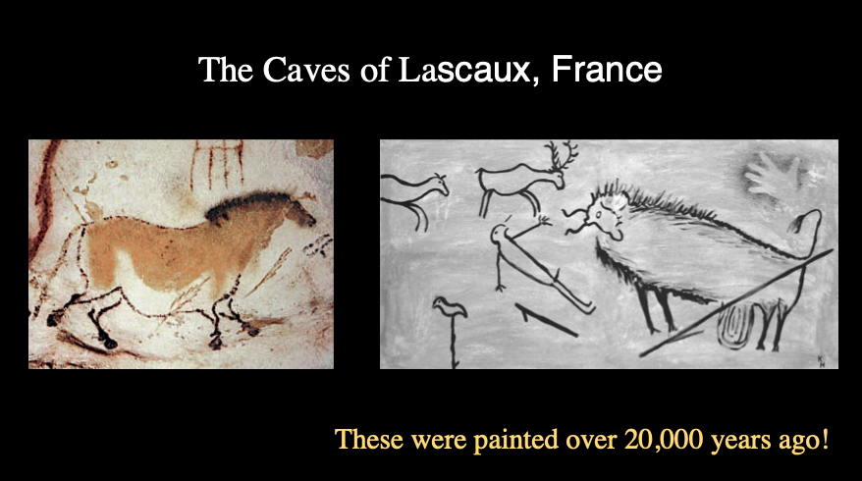
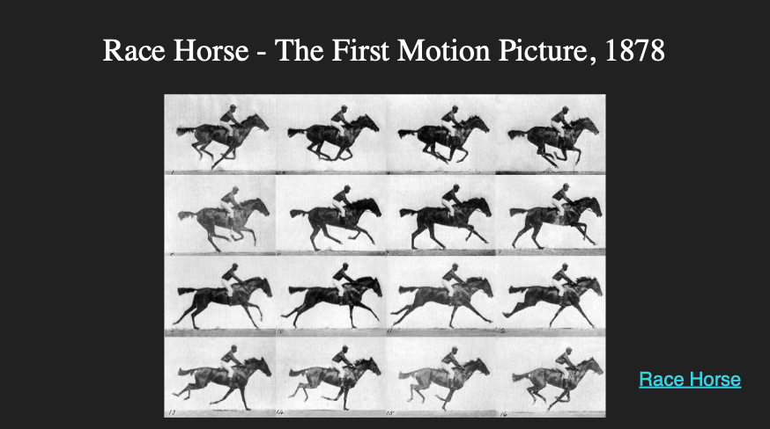
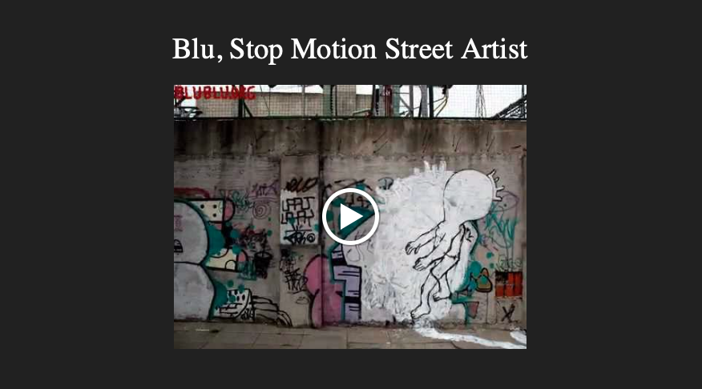

Animating Inanimate Objects
How do we give life to an object? It’s all about copying human emotions! Have you ever heard the expression to ‘look lively’ or ‘look alive’? In most cases, we’re referring to another living person, but we want them to show more emotion. The first step to animating an inanimate object is to give it emotion, then translating that emotion into movement.

1. Pick and draw one inanimate object. When thinking about making this object move, it’s best to think of it as like a human body; where would it’s head be? It's waist? Could any parts of your object act as limbs? Take your drawing and label the Head, Shoulder Line, Waist-Line, and others if you spot any! (like in the picture below).
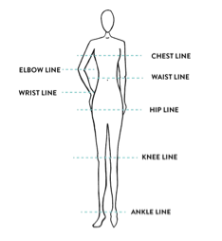

2. Take your object and give it emotion. Think about the bodily responses to emotions; if someone is sad, they may be hunched over, looking down at the ground. If someone is jealous, maybe they’re peering around a corner. How could your object look angry? Pick and draw your object as 6 different emotions. (some examples: disgust, depression, surprise, pride, guilt, confusion, bored, shy, enraged)

3. What makes your object unique? What do they like to do for fun? What gets on their nerves? What is their favorite song? What is it’s favorite subject in school? List five things about your objects personality that makes it different!
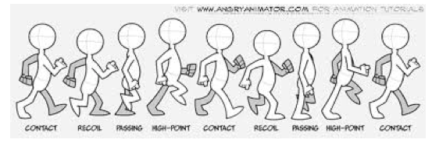
4. Take a look at this illustration of the walk cycle and think back to the stop-motion animations you saw at the beginning of class. Think about how many frames needed to be drawn just to show one movement. Next, take everything you know about your object and give it life! In a minimum of 12 frames, draw your object looking lively; maybe they’re jumping for joy, or shaking with fear, or even .
*Pick specific ways to show these emotions; it should be clear whether your object is lazy or sleepy, sad or depressed, annoyed or angry.

Bibliography
https://youtu.be/ViTDhlxNCds - Mickey Mouse Animation
https://youtu.be/nYhmq3vo7aY - Cave Paintings of Lascaux
https://youtu.be/heRuLp7CyTM - Horse in Motion
https://youtu.be/-NCArUIOZCs - Gumby
https://www.youtube.com/watch?v=uuGaqLT-gO4 - Blu
https://www.youtube.com/watch?v=qZefKaANfe0 - Kubo
https://www.youtube.com/watch?v=0i29loX06A4 - Boxtrolls BTS
https://www.youtube.com/watch?v=xlGTz0pSLS8 - “Carmen” Georges Bizet
https://www.youtube.com/watch?v=UKftOH54iNU - “Carmen” Stromae
Lascaux - Cave Paintings
http://100photos.time.com/photos/eadweard-muybridge-horse-in-motion -- 1878 Running Horse
https://www.youtube.com/watch?v=uuGaqLT-gO4 - Blu Muto video
http://rubistar.4teachers.org/index.php thats for the rubric
https://play.google.com/store/apps/details?id=com.cateater.stopmotionstudio&hl=en_US that is the link for the app.
http://www.corestandards.org/ELA-Literacy/RL/9-10/#CCSS.ELA-Literacy.RL.9-10.7

